

SafePressure Alert

Mastering Embedded System Online Diploma

[www.learn-in-depth.com](http://www.learn-in-depth.com)

Requirements Analysis Document

**First Term (Final Project 1)**

Eng. Abdallah Shabaan Ghazy

email:[abdallah.shabaan.ghazy@gmail.com](mailto:abdallah.shabaan.ghazy@gmail.com)

**My Profile:**

<https://www.learn-in-depth-store.com/certificate/abdallah.shabaan.ghazy%40gmail.com>

### **Requirements Analysis for Pressure Control System (PCS)**

**Version 1.0 approved**

**Prepared by:** Abdallah Shabaan Ghazy

**Organization:** learn in depth

**Date Created:** 8/11/2024

## ****1. Introduction****

### **1.1 Purpose**

### This document provides a detailed analysis of the requirements for the Pressure Control System. It aims to clarify and elaborate on the requirements to ensure that the system meets the needs of the client and performs as expected.

### **1.2 Scope**

### The Pressure Control System is designed to monitor cabin pressure and alert the crew when the pressure exceeds 20 bars. The system will include an alarm that lasts for 60 seconds and optionally stores pressure values.

### **1.3 Definitions and Acronyms**

### **Pressure Control System (PCS):** The system being analyzed and developed.

### **Alarm:** A signal, either audible or visual, that alerts the crew to a condition where the pressure exceeds 20 bars.

### **Cabin:** The enclosed space where pressure is monitored.

### **Flash Memory:** Storage used for keeping recorded pressure values.

**Definitions, acronyms, and abbreviations**

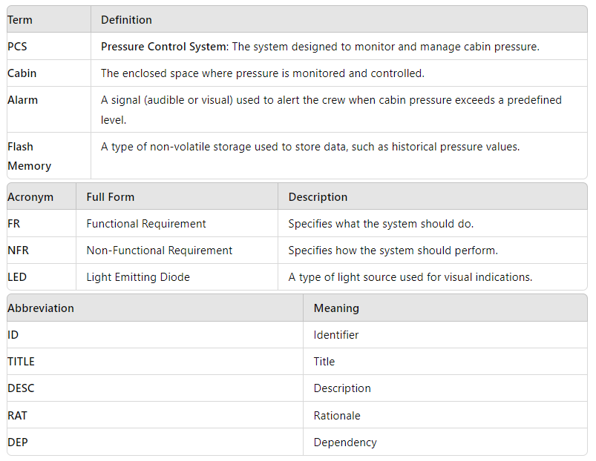

## ****2. Requirements****

##### **2.1 Functional Requirements**

#### This section includes the requirements that specify all the fundamental actions of the software system.

##### **2.1.1 High Pressure Detection**

* **ID:** FR1
* **TITLE:** Check for High Pressure in the Cabin
* **DESC:** The system shall continuously monitor the cabin pressure and detect when it exceeds 20 bars.
* **RAT:** To ensure the cabin pressure does not exceed safe levels.
* **DEP:** None

##### **2.1.2 Pressure Threshold Checking**

* **ID:** FR2
* **TITLE:** Check Pressure Against Threshold
* **DESC:** The system shall check if the pressure is below a predefined threshold of 20 bars.
* **RAT:** To verify that the pressure monitoring is functioning correctly.
* **DEP:** FR1

##### **2.1.3 Reading from Pressure Sensor**

* **ID:** FR3
* **TITLE:** Read Data from Pressure Sensor
* **DESC:** The system shall read the pressure values from the pressure sensor continuously.
* **RAT:** To provide accurate and real-time pressure data to the system.
* **DEP:** FR2

##### **2.1.4 Crew Notification**

* **ID:** FR4
* **TITLE:** Inform Crew of High Pressure
* **DESC:** The system shall notify the crew when the pressure in the cabin exceeds 20 bars.
* **RAT:** To ensure that the crew is aware of unsafe pressure conditions and can take necessary actions.
* **DEP:** FR1

##### **2.1.5 Alarm Activation**

* **ID:** FR5
* **TITLE:** Activate Alarm with LED
* **DESC:** The system will activate an alarm by turning on an LED for a duration of 60 seconds when the pressure exceeds the threshold.
* **RAT:** To provide a clear visual indication of high pressure to the crew.
* **DEP:** FR4

##### **2.1.6 Optional Storing of Pressure Values**

* **ID:** FR6
* **TITLE:** Store Pressure Values in Flash Memory
* **DESC:** The system shall optionally store pressure values in flash memory for future reference.
* **RAT:** To provide a historical record of pressure readings for analysis.
* **DEP:** None

#### **2.2 Performance Requirements**

The requirements in this section provide a detailed specification of the user interaction with the software and measurements placed on the system performance.

##### **2.2.1 Response Time for Pressure Detection**

* **ID:** NFR1
* **TITLE:** Response Time for Pressure Detection
* **DESC:** The system must detect pressure changes and activate the alarm within 2 seconds of the pressure exceeding the threshold.
* **RAT:** To ensure timely response to dangerous pressure levels.
* **DEP:** FR1, FR2

##### **2.3 Software System Attributes**

#### This section specifies the required reliability, availability, security, and maintainability of the software system.

##### **2.3.1 Reliability**

* **ID:** NFR2
* **TITLE:** System Reliability
* **DESC:** The system must operate reliably under all specified conditions without failure.
* **RAT:** To ensure continuous monitoring and alert functionality.
* **DEP:** FR1, FR2

##### **2.3.2 Availability**

* **ID:** NFR3
* **TITLE:** System Availability
* **DESC:** The system should be available and operational at all times, with minimal downtime.
* **RAT:** To provide constant monitoring and timely alerts.
* **DEP:** FR1, FR2

##### **2.3.3 Security**

* **ID:** NFR4
* **TITLE:** Secure Communication
* **DESC:** The system should ensure secure communication between pressure sensors and the alarm system and be reliable to avoid false alarms or failures.
* **RAT:** To maintain system integrity and trustworthiness.
* **DEP:** FR1, FR3

##### **2.3.4 Maintainability**

* **ID:** NFR5
* **TITLE:** Maintainability
* **DESC:** The system should be designed for ease of maintenance, with clear documentation and support for troubleshooting and updates.
* **RAT:** To ensure that the system can be effectively maintained and updated as needed.
* **DEP:** FR1, FR2

### **3. System Constraints**

#### **3.1 Technical Constraints**

* The system must integrate with existing pressure measurement devices in the cabin.
* The alarm system must be designed to operate effectively within the cabin's environmental conditions (e.g., noise levels, lighting).

#### **3.2 Regulatory Constraints**

* The system must comply with industry standards and regulations for pressure monitoring and alarm systems.

### **4. Assumptions**

* It is assumed that the cabin will have reliable pressure sensors capable of interfacing with the control system.
* It is assumed that the crew will receive adequate training on how to handle the alarm system.

### **5. Dependencies**

* The successful implementation of the system depends on the availability of compatible pressure sensors and alarm hardware.
* Coordination with the cabin's maintenance team is required to ensure proper integration and operation.

### **6. Risks**

* **False Alarms:** The risk of false alarms if the pressure sensors or alarm system malfunction.
* **Sensor Accuracy:** The risk of inaccurate pressure readings affecting the system's performance.

#### **7. References**

## requirement gathering

**Requirement diagram**

